BOURNE ABBEY CHURCH OF ENGLAND PRIMARY ACADEMY

Executive Headteacher: Mrs S J Moore

Head of School: Mrs S L Buttress
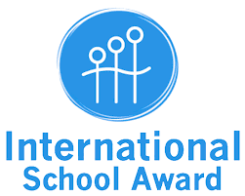
Abbey Road Tel: 422163
Bourne
11th May 2021

Dear Parents/Carers,
INTERNATIONAL SCHOOL AWARD
At Bourne Abbey, we have been working very hard towards the reaccreditation of our International School Award over the course of this academic year. Year 5 have been extremely fortunate in that they have had the opportunity to participate in a partnered activity, in collaboration with a girls’ secondary school in Pakistan.

The Alphabet Project involved our students teaching the students in Pakistan the English alphabet, and them teaching our children the Urdu alphabet. What makes the successful completion of this task even more remarkable is that parts of the activity – in both countries – were undertaken remotely during lockdown!

The feedback from both our students and theirs has been overwhelmingly positive. I am extremely proud of the way that the Year 5 pupils at Bourne Abbey were so receptive to and enthusiastic about learning the Urdu alphabet – especially given that the letter system is completely different to English! I hope that if you ask your child about this activity, they will be able to tell you how it was achieved and tell you about their experience of learning the alphabet in Urdu!

I wondered if you might be able to find the time to complete the parent/carer evaluation attached. This would be used as evidence towards our reaccreditation and may be quoted in the final paperwork we need to send off to the British Council in our quest to retain our award.

I would appreciate it if you could return any completed forms by email to BAP.enquiries@abbeyacademies.co.uk by Friday 14th May 2021.

Many thanks,

Mrs Kirsten Parriss
French Teacher and International Coordinator

